**Assignment Day 8**

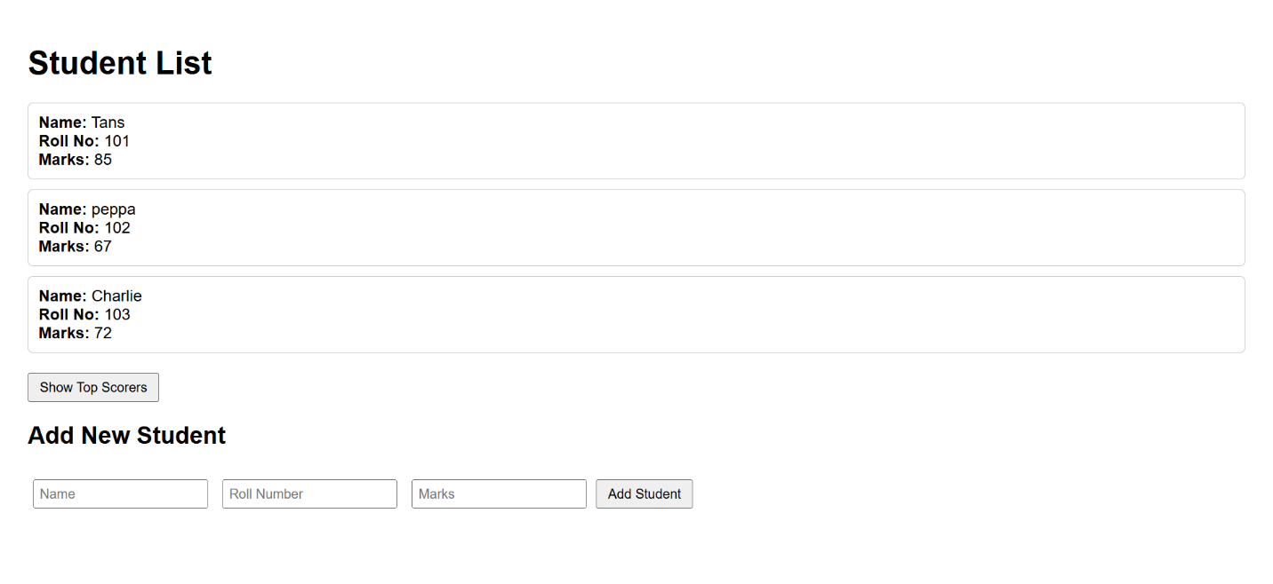

Today’s task involved creating a simple student management system using HTML and JavaScript. An array of student objects was created, each containing a name, roll number, and marks. The data was dynamically displayed on a web page. A filter feature was added to show only students who scored above 70 marks using a button. Additionally, a form was included to allow users to add new students to the list, which updates in real time on the page.